**GAME NAME**: SEA LEVEL RISE GAME PROPOSAL

# Project Description:

This project focuses on climate resilience with an emphasis on behavior change. Behavior at the urban and household levels contributes roughly 72% of annual greenhouse gases to the atmosphere (Hertwich and Peters, 2009). Previous research has shown that behavior change is essential to addressing climate challenges. In this regard, many climate adaptation plans anticipate that stakeholders will modify their actions while working towards enhancing resilience. However, “so far, behavioral aspects have received limited attention in the evaluation approaches for climate adaptation planning (Walawalkar et al., 2022).” Further, there has been a recent increase in interest in the use of serious games (defined as a game with a goal that targets social impact, such as behavior change) and gamification for sustainability and citizen engagement (e.g., Silva and Analide, 2016). Yet, more research is needed to understand how serious games can support sustainable behavior change and effective decision-making for climate resilience.

Within this context, we propose to develop a serious game that focuses on the challenges of the sea level rise problem. The player will see the effect of rainfall on the sea level rise and will be given the option to help people living on the sea shore to move up to a nearby hill.

# List of expected features:

* **Increasing/decreasing Rain:** With climate change, rain will increase in some parts of the land while decrease in other parts. Rain increase will lead to flooding and rain decrease will lead to drought. Players in the game will have the option to increase or decrease the rain affecting the sea level and hence affecting the people on the land to decide to stay or leave (migrate) as seen in the next features.
* **Changing Sea Level:** In relation to increased/decreased rain, the sea level will be affected. Players in the game will be able to monitor and change the sea level using millis.
* **Staying/leaving people:** Players will be given the option to leave people in the land and hence be more affected by the effects of climate change (flooding / drought) or help them to leave the land to a higher elevation and get protected from the sea level rise.

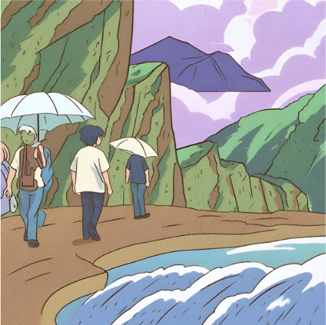

*Image is created by Canva AI generator using the prompt” show an abstract image including: rainfall, sea level rise, people on a land, nearby one hill*

# A detailed and ordered list of each development task that needs to be done and the order to do them

State 1: Start of the game

# First, an initial page will introduce the player to the game. The player will press a specific key to start the game.

State 2: Playing the game

* Purple rain will start to fall, and the player will see some people on land and a nearby hill.
* The player will have a title screen on which a given key is pressed to start the countdown timer.
* The player will have the option to reduce or increase the rainfall by pressing a given key. This action will also affect the sea level rise by millis (still not sure if we will include this feature or just make the game start with rainfall) .
* The player will have the option to keep the people in the same land or move the people forward to a nearby hill by pressing another given key.
* The player may implement a system of gear shifting or another method of changing the people’s speed to leave the land (still not sure if we will include this feature).

State 3 and 4: Ending the game

* Winning the game: saving all the people by moving them to the hill
* Game over: not saving all the people (i.e. one of the people drowns by the sea level rise)
* A given key allows the game to restart when on the results screen

# Citations

* Hertwich, E.G. and Peters, G.P., 2009. Carbon footprint of nations: a global, trade- linked analysis. Environmental science & technology, 43(16), pp.6414-6420.
* Silva, F. and Analide, C., 2016, October. Gamification and the Improvement of Urban Sustainability. In Intelligent Environments (Workshops) (pp. 446-455).
* Walawalkar, T.P., Hermans, L.M. and Evers, J., 2022. Evaluating behavioural changes for climate adaptation planning. Journal of Environmental Planning and Management, 66(7), pp.1453-1471.